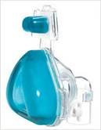

Cellulitis

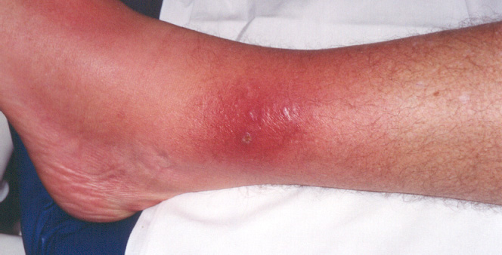

What is cellulitis?
Cellulitis is an infection of the deep layer of skin (dermis) and the layer of fat and other tissues just under the skin (the subcutaneous tissues).

What causes cellulitis?
The skin is usually a good barrier against infection but a break in the skin, be it from a cut, skin ulcer, infection, athlete's foot or badly scratched eczema for example, is a way in which bacteria (germs) can get into and under the skin.

A variety of bacteria can cause cellulitis.
A tiny cut is all that is needed to let bacteria in. The bacteria then multiply and spread under the skin’s surface to form an infection.

Although a cut or graze is found in many cases to be the main cause, sometimes the infection can occur for no apparent reason without the skin being broken.

Who gets cellulitis?
Cellulitis can affect anyone but you are more likely to get cellulitis if you:
- have athlete's foot (see below)
- have swollen legs (for various reasons)
- are overweight
- have had cellulitis before
- have a poor immune system
- have poorly controlled diabetes
- have had an insect bite

Cellulitis can be treated but it may come back if the cause is not also treated. A common cause of cellulitis is athlete's foot, which can easily be missed as the source of the problem. It is usually a mild fungal infection which can cause itchiness and tiny cracks in the skin between the toes. Bacteria may then get under the skin and travel up to cause a cellulitis in the leg, without looking like there is an infection of the foot.

People that are more likely to get cellulitis, like those with swollen legs or those who are overweight, should be careful to treat any athlete's foot promptly.

How do I know I have cellulitis?
The affected skin feels warm, may look swollen, and looks red and inflamed. The infected area may spread and is usually tender. The nearest glands may swell and become tender. This is because they are fighting off the infection to stop it spreading to other parts of the body.

The glands in the groin may swell during a cellulitis of the leg. You may feel generally unwell and have a fever, particularly if the area of infection is large. The lower leg is the most common site for cellulitis to develop but it can affect any area of the skin.

Is cellulitis serious?
Cellulitis can range from a small area to a large area of spreading infection affecting a large area of skin. This means that cellulitis can range from mild to serious. Without treatment, a 'battle' is fought between the immune (defence) system of the body and the invading bacteria.

Often the body will fight off the bacteria and the infection will clear but a spreading cellulitis that is getting worse will require prompt treatment to make sure it does not spread and become more serious.

What is the treatment for cellulitis?
A course of antibiotic tablets will usually clear cellulitis. Symptoms should soon ease once you start antibiotic tablets (you may see an initial increase in redness when treatment is started before it starts to fade.)

People with more severe cellulitis or those not improving with antibiotic tablets may need antibiotic injections given straight into a plastic tube in a vein, these are called intravenous antibiotics.

The Community Nurse will assess your cellulitis at each visit. Please ensure you tell your Community Nurse if the area of infection continues to spread or you feel more unwell at any time.

Some bacteria are resistant to some antibiotics, so a change in antibiotic may be needed if the infection does not improve with the first antibiotic.

How is the antibiotic injection given?
A cannula (small hollow plastic tube) is inserted into the vein and the antibiotic is given either as a direct injection or as a drip over 30 minutes. The antibiotics are given daily and the whole process should take about one hour. The cannula will be left in between visits and secured with a transparent dressing.

How long do I need to have the intravenous antibiotics?
The cellulitis should improve after 3 to 4 days and the treatment can then be given as tablets until the infection has cleared up. The Community Nurse will discuss this with you and assess the cellulitis daily to see whether it is responding to treatment. If the infection does not improve then you may have to be admitted to hospital.
What can I do to help?
Painkillers such as paracetamol can ease pain and reduce a fever; the Community Nurse will discuss this with you.

If you have cellulitis of the leg, keep the leg raised when you are resting. This helps to prevent excess swelling, which may also ease pain. 'Raised' means that your foot is higher than your hip so gravity helps to reduce the swelling. The easiest way to raise your leg is to lie on a sofa with your leg up on a cushion. When in bed, put your foot on a pillow so that it is slightly higher than your hip.

If the cellulitis is in the forearm or hand, a high sling can help to raise the affected area to reduce swelling and pain.

Treat athlete’s foot if it is present. As the infection clears and the skin begins to heal, use a moisturising cream to keep the skin supple and moist.

Time to heal
The swelling, warmth, and redness should begin to improve within one to three days after starting antibiotics, although these symptoms can persist for two weeks. Like a skin burn, the skin may take several weeks to heal and there may be residual scarring.

If you have any concerns about your condition or your treatment, please contact your Community Nurse.

To contact a Community Nurse please call the appropriate number below:

Birmingham Patients | Solihull Patients | South Staffordshire Patients
0300 555 1919 Option 2  (24 hours) | 0121 717 4333  (24 hours) | 01827 263884  (24 hours)

Our commitment to confidentiality
We keep personal and clinical information about you to ensure you receive appropriate care and treatment. Everyone working in the NHS has a legal duty to keep information about you confidential. We will share information with other parts of the NHS to support your healthcare needs, and we will inform your GP of your progress unless you ask us not to.

If we need to share information that identifies you with other organisations we will ask for your consent. You can help us by pointing out any information in your records which is wrong or needs updating.

Additional Sources of Information:
Go online and view NHS Choices website for more information about a wide range of health topics http://www.nhs.uk/Pages/HomePage.aspx

You may want to visit one of our Health Information Centres located in:
- Main Entrance at Birmingham Heartlands Hospital Tel: 0121 424 2280
- Treatment Centre at Good Hope Hospital Tel: 0121 424 9946
or contact us by email: healthinfo.centre@heartofengland.nhs.uk.

Dear Patient

We welcome your views on what you liked and suggestions for how things could be improved at this hospital. If you would like to tell us and others about your experience please make your comments through one of the following sites:-

- NHS Choice:- www.nhs.uk
- Patient Opinion:- www.patientopinion.org.uk
- I want great care:- www.iwantgreatcare.org (Here you can leave feedback about your doctor)

Be helpful and respectful: think about what people might want to know about this hospital or how your experiences might benefit others. Remember your words must be polite and respectful, and you cannot name individuals on the NHS Choice or Patient Opinion sites.

If you have any questions you may want to ask about your condition or treatment, or anything you do not understand or wish to know more about, write them down and your doctor will be more than happy to try and answer them for you.

